PRACTICAL 1

Aim: Installation of PostgreSQL. Also, study difference between PostgreSQL and Oracle SQL. Study various data types of oracle SQL in detail.

Software required: PostgreSQL

Download PostgreSQL Installer for Windows
You need to download the installer from PostgreSQL Official website.
- Go to the PostgreSQL official website, download section for Windows http://www.postgresql.org/download/windows/
- Click on the download installer from EnterpriseDB
- Choose the latest version to download. It takes few minutes to complete the download.

Install PostgreSQL step by step
Double click on the installer file, an installation wizard will appear and guide you through multiple steps where you can choose different options that you would like to have in PostgreSQL.

The following illustrates each step and its options for installation. If you install a different version, you may get additional steps.
Start Installing PostgreSQL
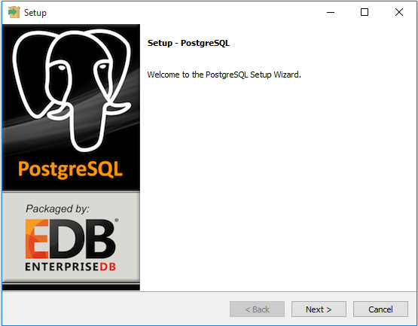
Specify installation folder, choose your own or keep the default folder suggested by PostgreSQL installer.
Enter the password for the database superuser and service account.
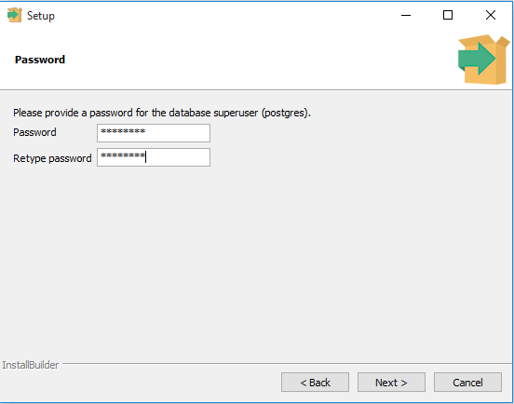
Enter the port for PostgreSQL. Make sure that no other applications are using this port. Leave it as default if you are unsure.
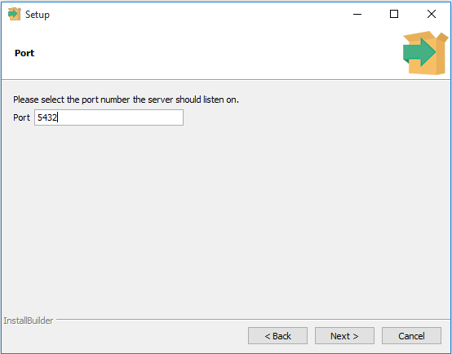
Choose the default locale used by the database.
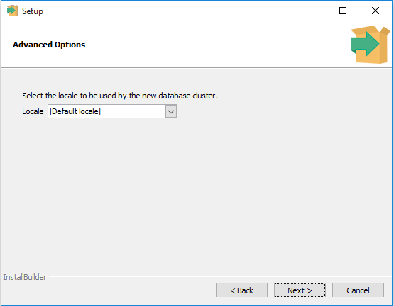
You’ve completed providing information for the PostgreSQL installer. Click the Next button to install PostgreSQL
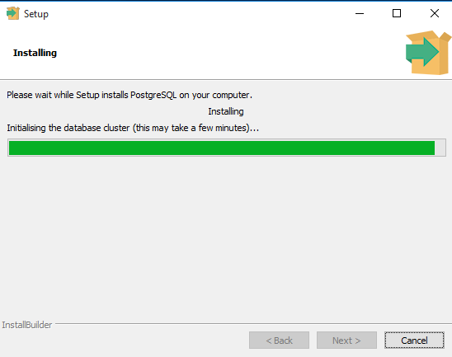
The installation may take few minutes to complete.
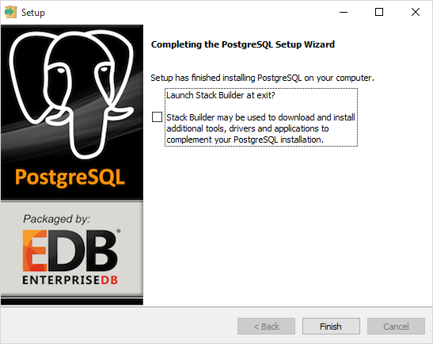
Click the Finish button to complete the PostgreSQL installation.

Verify the Installation
There are several ways to verify the installation. You can try to connect to the PostgreSQL database server from any client application e.g., psql and pgAdmin.
The quick way to verify the installation is through the pgAdmin application.
First, click on pgAdmin III to launch it. The pgAdmin III GUI will display.
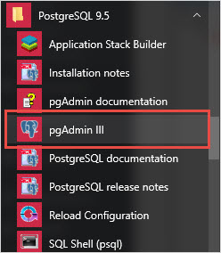
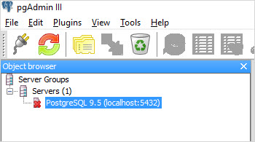
Second, double-click PostgreSQL 9.5 on the object browser. It will ask you for the admin password. Just enter the password you’ve used in the installation step.
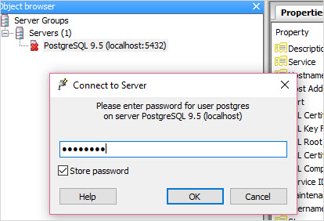
Third, if everything is fine, the pgAdmin will display all the objects that belong to the server.
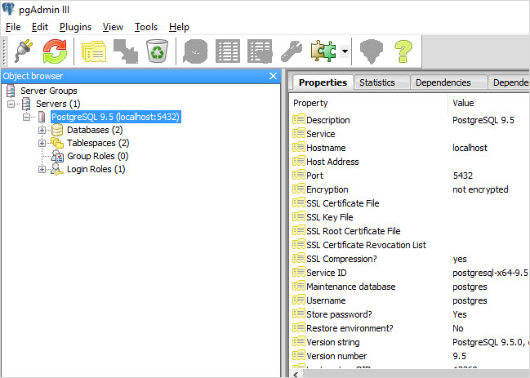

PRACTICAL 2

Aim: Create tables and insert records in it as per given schema in PostgreSQL and Oracle SQL.

Software required: Oracle SQL

Knowledge required: Data type in SQL, Schema

1* create table job(job_id varchar2(15),job_title varchar2(30),min_sal number(7,2),max_sal number
SQL> /
Table created.

1* create table employee(emp_no number(3),emp_name varchar2(30),emp_sal number(8,2),emp_comm numb
SQL> /
Table created.

1* Create table deposit(a_no varchar2(5),cname varchar2(15),bname varchar2(10) ,amount number(7,2
SQL> /
Table created.

1* Create table borrow(loanno varchar2(5),cname varchar2(15),bname varchar2(10),amount number(7,2
SQL> /
Table created.

SQL>desc job;
Name Null? Type
----------------------------------------- -------- ----------------------------
JOB_ID VARCHAR2(15)
JOB_TITLE VARCHAR2(30)
MIN_SAL NUMBER(7,2)
MAX_SAL NUMBER(7,2)

SQL>desc employee;
Name Null? Type
----------------------------------------- -------- ----------------------------
EMP_NO NUMBER(3)
EMP_NAME VARCHAR2(30)
EMP_SAL NUMBER(8,2)
EMP_COMM NUMBER(6,1)
DEPT_NO NUMBER(3)

SQL>desc deposit;
Name Null? Type
----------------------------------------- -------- ----------------------------
A_NO VARCHAR2(5)
CNAME VARCHAR2(15)
BNAME VARCHAR2(10)
AMOUNT NUMBER(7,2)
A_DATE DATE

SQL>desc borrow;
Name Null? Type
----------------------------------------- -------- ----------------------------
LOANNO VARCHAR2(5)
CNAME VARCHAR2(15)
BNAME VARCHAR2(10)
AMOUNT NUMBER(7,2)

1* insert into employee values(&emp_no,&emp_name,&emp_sal,&emp_comm,&dept_no)
SQL> /
Enter value for emp_no: 101
Enter value for emp_name: 'smith'
Enter value for emp_sal: 800
Enter value for emp_comm: 0
Enter value for dept_no: 20
old 1: insert into employee values(&emp_no,&emp_name,&emp_sal,&emp_comm,&dept_no)
new 1: insert into employee values(101,'smith',800,0,20)

1 row created.

SQL> /
Enter value for emp_no: 102
Enter value for emp_name: 'snehal'
Enter value for emp_sal: 1600
Enter value for emp_comm: 300
Enter value for dept_no: 25
old1: insert into employee values(&emp_no,&emp_name,&emp_sal,&emp_comm,&dept_no)
new 1: insert into employee values(102,'snehal',1600,300,25)

1 row created.

SQL> /
Enter value for emp_no: 103
Enter value for emp_name: 'adama'
Enter value for emp_sal: 1100
Enter value for emp_comm: 0
Enter value for dept_no: 20
old 1: insert into employee values(&emp_no,&emp_name,&emp_sal,&emp_comm,&dept_no)
new 1: insert into employee values(103,'adama',1100,0,20)

1 row created.

SQL> /
Enter value for emp_no: 104
Enter value for emp_name: 'aman'
Enter value for emp_sal: 3000
Enter value for emp_comm: 0
Enter value for dept_no: 15
old 1: insert into employee values(&emp_no,&emp_name,&emp_sal,&emp_comm,&dept_no)
new 1: insert into employee values(104,'aman',3000,0,15)

1 row created.

SQL> /
Enter value for emp_no: 105
Enter value for emp_name: 'anita'
Enter value for emp_sal: 5000
Enter value for emp_comm: 50000
Enter value for dept_no: 10
old 1: insert into employee values(&emp_no,&emp_name,&emp_sal,&emp_comm,&dept_no)
new 1: insert into employee values(105,'anita',5000,50000,10)

1 row created.

SQL> /
Enter value for emp_no: 106
Enter value for emp_name: 'sneha'
Enter value for emp_sal: 2450
Enter value for emp_comm: 24500
Enter value for dept_no: 10
old 1: insert into employee values(&emp_no,&emp_name,&emp_sal,&emp_comm,&dept_no)
new 1: insert into employee values(106,'sneha',2450,24500,10)

1 row created.

SQL> /
Enter value for emp_no: 107
Enter value for emp_name: 'anamika'
Enter value for emp_sal: 2975
Enter value for emp_comm: 0
Enter value for dept_no: 30
old 1: insert into employee values(&emp_no,&emp_name,&emp_sal,&emp_comm,&dept_no)
new 1: insert into employee values(107,'anamika',2975,0,30)

1 row created.

1* insert into job values(&job_id, &job_title, &min_sal, &max_sal)
SQL> /
Enter value for job_id: 'it_prog'
Enter value for job_title: 'programmer'
Enter value for min_sal: 4000
Enter value for max_sal: 10000
old 1: insert into job values(&job_id, &job_title, &min_sal, &max_sal)
new 1: insert into job values('it_prog', 'programmer', 4000, 10000)

1 row created.

SQL> /
Enter value for job_id: 'mk_mgr'
Enter value for job_title: 'marketing manager'
Enter value for min_sal: 9000
Enter value for max_sal: 15000
old 1: insert into job values(&job_id, &job_title, &min_sal, &max_sal)
new 1: insert into job values('mk_mgr', 'marketing manager', 9000, 15000)

1 row created.

SQL> /
Enter value for job_id: 'fi_mgr'
Enter value for job_title: 'finance manager'
Enter value for min_sal: 8200
Enter value for max_sal: 12000
old 1: insert into job values(&job_id, &job_title, &min_sal, &max_sal)
new 1: insert into job values('fi_mgr', 'finance manager', 8200, 12000)

1 row created.

SQL> /
Enter value for job_id: 'fi_acc'
Enter value for job_title: 'account'
Enter value for min_sal: 4200
Enter value for max_sal: 9000
old 1: insert into job values(&job_id, &job_title, &min_sal, &max_sal)
new 1: insert into job values('fi_acc', 'account', 4200, 9000)

1 row created.

SQL> /
Enter value for job_id: 'lec'
Enter value for job_title: 'lecturer'
Enter value for min_sal: 6000
Enter value for max_sal: 17000
old 1: insert into job values(&job_id, &job_title, &min_sal, &max_sal)
new 1: insert into job values('lec', 'lecturer', 6000, 17000)

1 row created.

SQL> /
Enter value for job_id: 'comp_op'
Enter value for job_title: 'computer operator'
Enter value for min_sal: 1500
Enter value for max_sal: 3000
old 1: insert into job values(&job_id, &job_title, &min_sal, &max_sal)
new 1: insert into job values('comp_op', 'computer operator', 1500, 3000)

1 row created.

1* insert into deposit values(&a_no,&cname,&bname,&amount,&a_date)
SQL> /
Enter value for a_no: 101
Enter value for cname: 'anil'
Enter value for bname: 'andheri'
Enter value for amount: 7000
Enter value for a_date: '01-jan-06'
old 1: insert into deposit values(&a_no,&cname,&bname,&amount,&a_date)
new 1: insert into deposit values(101,'anil','andheri',7000,'01-jan-06')

1 row created.

SQL> /
Enter value for a_no: 102
Enter value for cname: 'sunil'
Enter value for bname: 'virar'
Enter value for amount: 5000
Enter value for a_date: '15-jul-06'
old 1: insert into deposit values(&a_no,&cname,&bname,&amount,&a_date)
new 1: insert into deposit values(102,'sunil','virar',5000,'15-jul-06')

1 row created.

SQL> /
Enter value for a_no: 103
Enter value for cname: 'jay'
Enter value for bname: 'villeparle'
Enter value for amount: 6500
Enter value for a_date: '12-mar-06'
old 1: insert into deposit values(&a_no,&cname,&bname,&amount,&a_date)
new 1: insert into deposit values(103,'jay','villeparle',6500,'12-mar-06')

1 row created.

SQL> /
Enter value for a_no: 104
Enter value for cname: 'vijay'
Enter value for bname: 'andheri'
Enter value for amount: 8000
Enter value for a_date: '17-sep-06'
old 1: insert into deposit values(&a_no,&cname,&bname,&amount,&a_date)
new 1: insert into deposit values(104,'vijay','andheri',8000,'17-sep-06')

1 row created.

SQL> /
Enter value for a_no: 105
Enter value for cname: 'keyur'
Enter value for bname: 'dadar'
Enter value for amount: 7500
Enter value for a_date: '19-nov-06'
old 1: insert into deposit values(&a_no,&cname,&bname,&amount,&a_date)
new 1: insert into deposit values(105,'keyur','dadar',7500,'19-nov-06')

1 row created.

SQL> /
Enter value for a_no: 106
Enter value for cname: 'mayur'
Enter value for bname: 'borivali'
Enter value for amount: 5500
Enter value for a_date: '21-dec-06'
old 1: insert into deposit values(&a_no,&cname,&bname,&amount,&a_date)
new 1: insert into deposit values(106,'mayur','borivali',5500,'21-dec-06')

1 row created.

SQL> select * from employee
2 /

EMP_NO EMP_NAME EMP_SAL EMP_COMM DEPT_NO
---------- ------------------------------ ---------- ---------- ----------
101 smith 800 0 20
102 snehal 1600 300 25
103 adama 1100 0 20
104 aman 3000 0 15
105 anita 5000 50000 10
106 sneha 2450 24500 10
107 anamika 2975 0 30

7 rows selected.

SQL> select * from job;

JOB_ID JOB_TITLE MIN_SAL MAX_SAL
--------------- ------------------------------ ---------- ----------
it_prog programmer 4000 10000
mk_mgr marketing manager 9000 15000
fi_mgr finance manager 8200 12000
fi_acc account 4200 9000
lec lecturer 6000 17000
comp_op computer operator 1500 3000

6 rows selected.

SQL> select * from deposit;

A_NO CNAME BNAME AMOUNT A_DATE
----- --------------- ---------- ---------- ---------
101 anil andheri 7000 01-JAN-06
102 sunil virar 5000 15-JUL-06
103 jay villeparle 6500 12-MAR-06
104 vijay andheri 8000 17-SEP-06
105 keyur dadar 7500 19-NOV-06
106 mayur borivali 5500 21-DEC-06

6 rows selected.

SQL> commit;

Commit complete.

Questions:
1. Which one of the following is used to define the structure of the relation ,deleting relations and relating schemas ?
a) DML(Data Manipulation Langauge)
b) DDL(Data Definition Langauge)
c) Query
d) Relational Schema
Answer:b
Explanation: Data Definition language is the language which performs all the operation in defining structure of relation.

2. Which one of the following provides the ability to query information from the database and to insert tuples into, delete tuples from, and modify tuples in the database ?
a) DML(Data Manipulation Langauge)
b) DDL(Data Definition Langauge)
c) Query
d) Relational Schema
Answer:a
Explanation: DML performs change in the values of the relation .

Practical-3

Aim: To Perform the queries using various row filtering operators.

Software required: Oracle SQL

- Retrieve all data from employee, jobs and deposit.
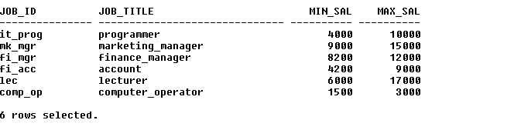
select * from job;

select * from employee;
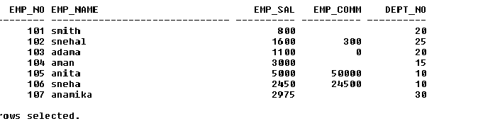

select * from deposit;
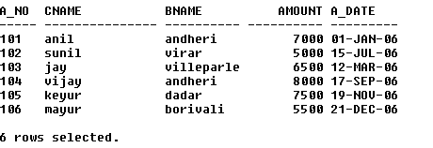

- Display job title and maximum salary of all jobs

selectjob_title, max_sal from job;
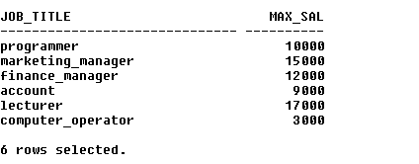
- Display the department of employee without duplication. What is the answer if you apply it to whole employee table?
select distinct dept_no from employee;

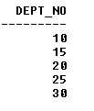
- Give details of account no. and deposited rupees of customers having account opened between dates 01-01-06 and 25-07-06.

selecta_no, amount from deposit where a_date between '01-JAN-06' and '25-JUL-06';

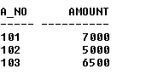

- Display all jobs with minimum salary is greater than 4000.

selectjob_title from job where min_sal>4000;
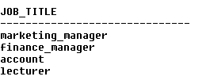
- Display name and salary of employee whose department no is 20. Give alias name to name of employee.
selectemp_name as name_employee, emp_sal from employee where dept_no in (20);

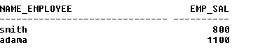
- Display employee no,name and department details of those employee whose department lies in(10,20).
selectemp_no, emp_name, dept_no from employee where dept_no in (10,20);

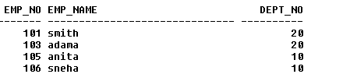

- Display employee no,name and department details of those employee whose department not in(20,30).

selectemp_no, emp_name, dept_no from employee where dept_no not in(20,30);

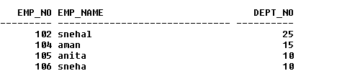

- Display employee no,name and department details of those employee whose department no is between 15 and 25.

selectemp_no, emp_name, dept_no from employee where dept_no between 15 and 25;

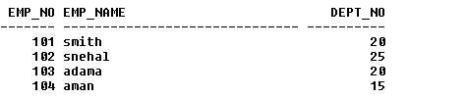
- Display the non-null values of employees.
select * from employee where emp_comm is not null;

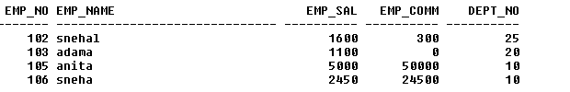

- Display name of customer along with its account no( both column should bedisplayed as one ) whose amount is not equal to 8000 Rs.
Select a_no||' '||cname as no_name from deposit where amount!= 8000;

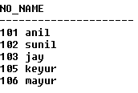
- Insert some duplicate values in deposit table and apply the concept of Distinct and also combine two columns and display it one column using common alias name.
insert into deposit values(103,'sunil','villeparle',6500,'12-mar-06');
1 row created.

select distinct a_no||' '||cname as no_name from deposit;

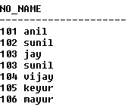

- Display the content of job details with minimum salary either 2000 or 4000.
select * from job where min_sal=2000 or min_sal=4000;

questions:

1. Select name ____ instructor name, course id
from instructor, teaches
where instructor.ID= teaches.ID;
Which keyword must be used here to rename the field name ?
a) From
b) Rename
c) As
d) Join
ViewAnswer
Answer:c
Explanation:As keyword is used to rename.

2. Select emp_name
from department
wheredept_name like ’ _____ Computer Science’;
Which one of the following has to be added into the blank to select the dept_name which has Computer Science as its ending string ?
a) %
b) _
c) ||
d) $
View Answer
Answer:a
Explanation:The % character matches any substring.

Practical-4

Aim: To study pattern matching using like predicate and escape sequence.

Software required: Oracle SQL

- Display all employee whose name start with ‘A’ and third character is ‘a’.
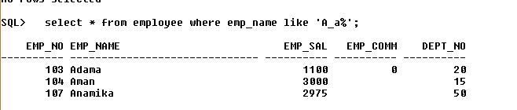

- Display name, number and salary of those employees whose name is 5 characters long and first three characters are ‘Ani’.
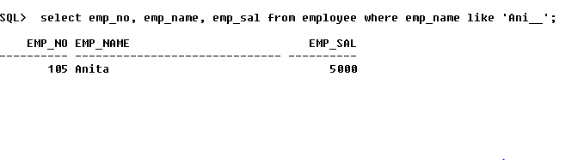

- Display all information of employee whose second character of name is either ‘M’ or ‘N’.
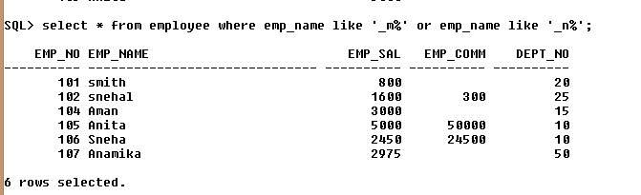
- Find the list of all customer name whose branch is in ‘andheri’ or ‘dadar’ or ‘virar’.
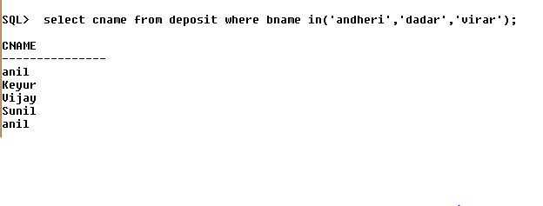
- Display the job name whose first three character in job id field is ‘FI_’.
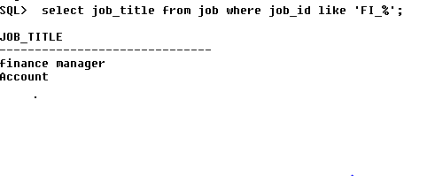
- Display the title/name of job whose last three character are ‘_MGR’ and there maximum salary is greater than Rs 12000.
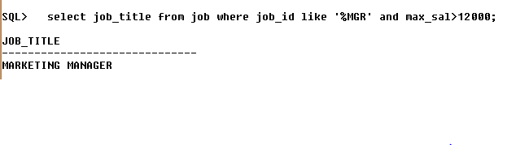

- Display the non-null values of employees and also employee name second character should be ‘n’ and string should be 5 character long.
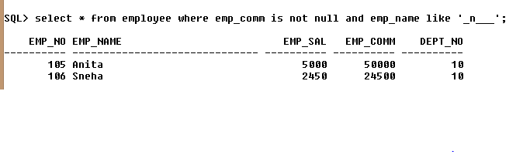
- Display the null values of employee and also employee name’s third character should be ‘a’.
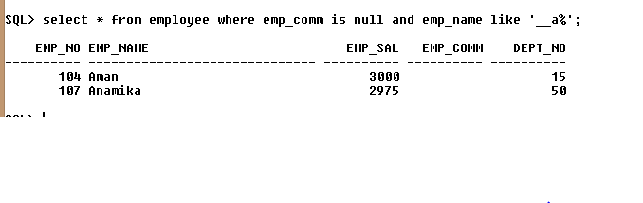
- What will be output if you are giving LIKE predicate as ‘%\_%’ ESCAPE ‘\’
select * from employee where emp_name like '%\_%'ESCAPE '\'

EMP_NO EMP_NAME EMP_SAL EMP_COMM DEPT_NO
6 abc_xyx 5000 523 41

questions:

1. For like predicate which of the following is true.
i) % matches zero of more characters.
ii) _ matches exactly one character.
a) i-only
b) ii-only
c) Both of the mentioned
d) None of the mentioned
Answer:a
Explanation:% is used with like and _ is used to fill in the character.

2. The number of attributes in relation is called as its
a) Cardinality
b) Degree
c) Tuples
d) Entity
Answer:b
Explanation:None.

3. _____ clause is an additional filter that is applied to the result.
a) Select
b) Group-by
c) Having
d) Order by
Answer:c
Explanation:Having is used to provide additional aggregate filtration to the query.

Practical-5

Aim: To perform various data manipulation commands and sorting concept.
Software required: Oracle SQL

- Create table supplier from employee with all the columns.
Query: create table supplier as select * from employee;
Output: Table created.
- Create table sup1 from employee with first two columns.
Query: create table sup1 as select EMP_NO,EMP_NAME from employee;
Output:
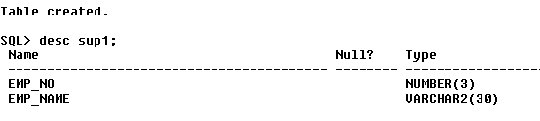
- Create table sup2 from employee with no data.
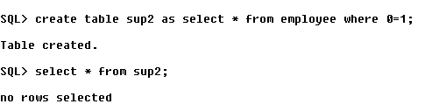
- Insert the data into sup2 from employee whose second character should be ‘n’ and string should be 5 characters long in employee name field.
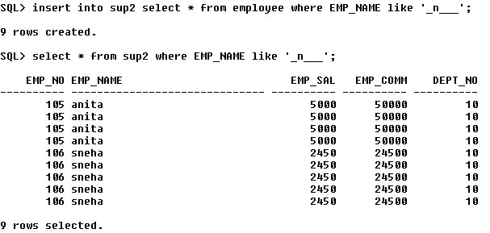
- Delete all the rows from sup1.
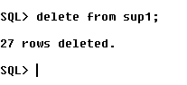
- Delete the detail of supplier whose emp_no is 103.
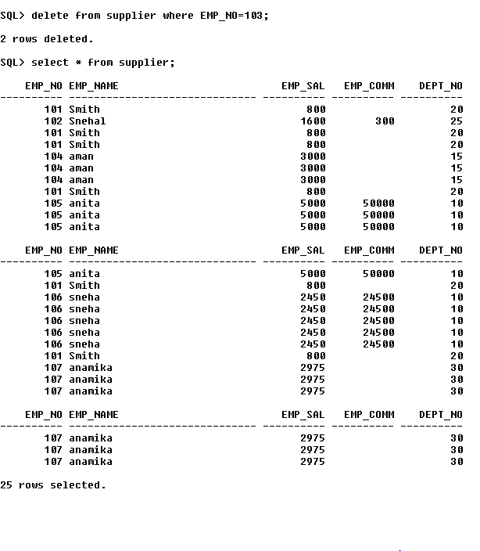
- Rename the table sup2.
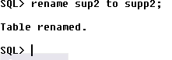
- Destroy table sup1 with all the data.
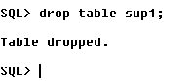
- Update the value dept_no to 10 where second character of emp. name is ‘m’.
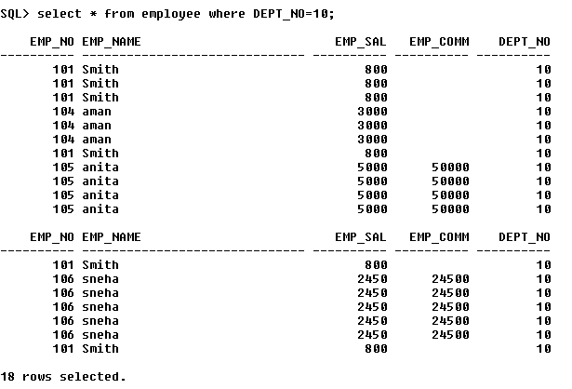
- Update the value of employee name whose employee number is 103.
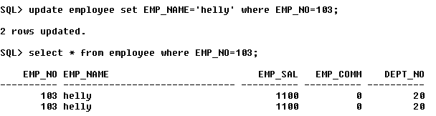
- Add one column phone to employee with size of column is 10.
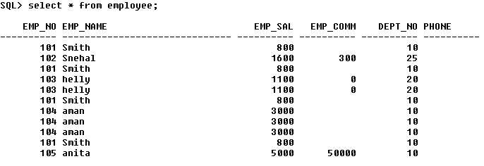
- Modify the column emp_name to hold maximum of 30 characters.
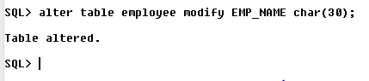
- Find out the maximum and minimum salary form job table.
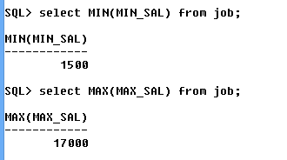
14.Find out the average salary of employee
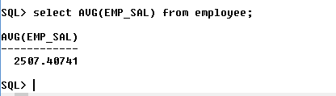
15.Count the total no as well as distinct rows in dept_no column with a condition of salary greater than 1000 of employee.
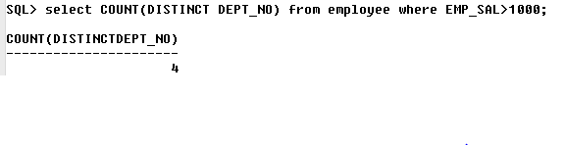
16.Display the detail of all employees in ascending order, descending order of their name and no.
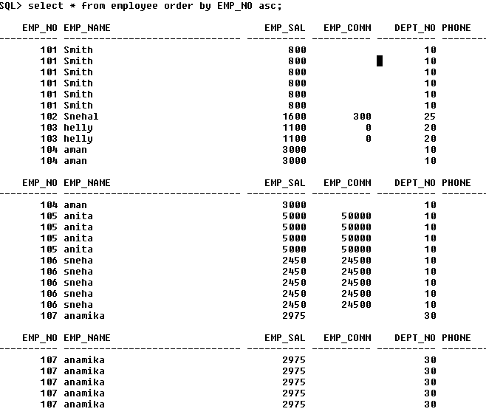
Output 2:-
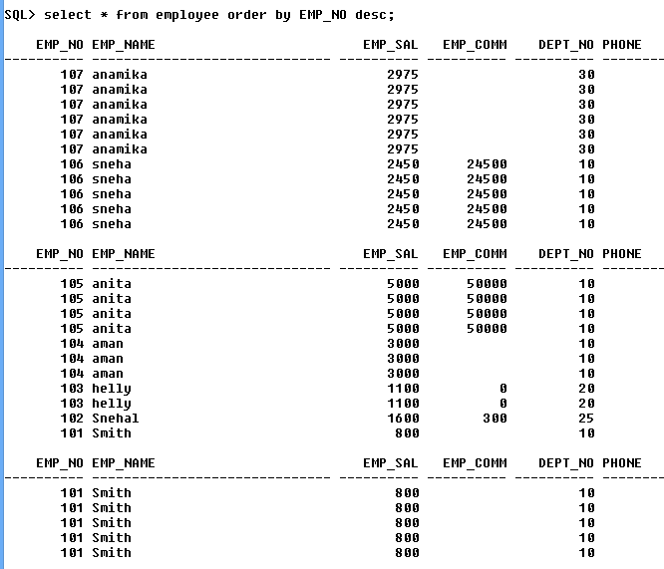

17.Display the dept_no in ascending order and accordingly display emp_comm in descending order.
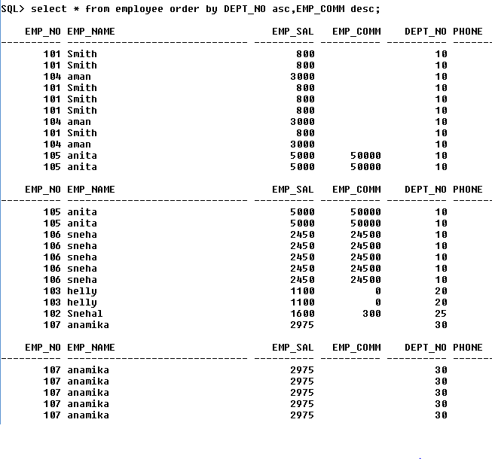
18.Display the value of emp_comm to 500 where dept_no is 20.
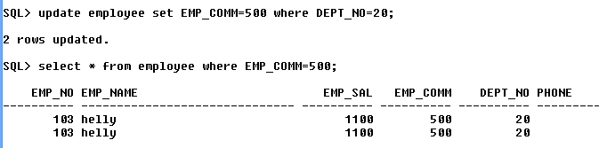
19.Display the emp_comm in ascending order with null value first and accordingly sort employee salary in descending order.
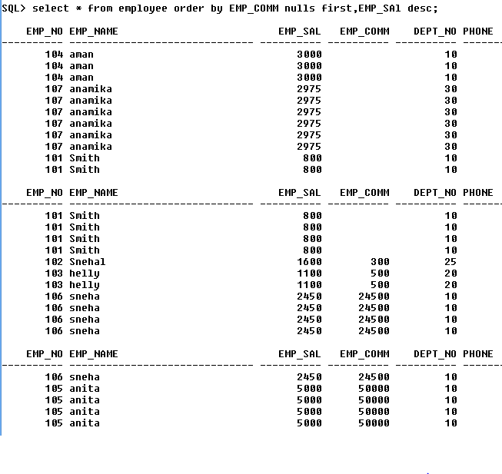

20.Display the emp_comm in ascending order with null value last and accordingly sort emp_no in descending order.
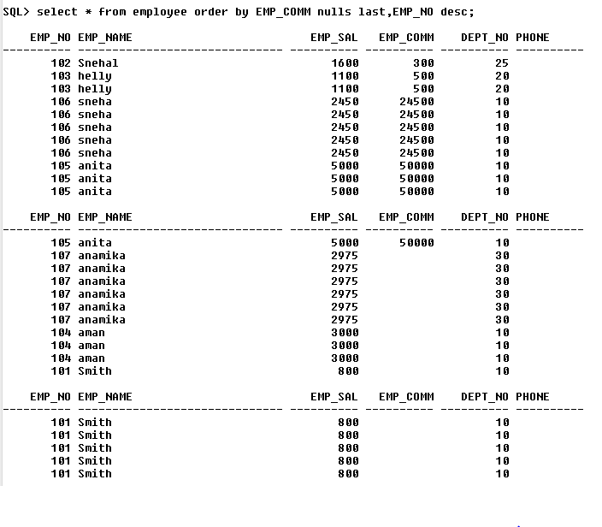

Practical 6

Aim:To Perform queries for all following oracle functions

- Aggregate function
- String functions
- Conversion function
- Date function
Software required: Oracle SQL

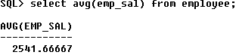

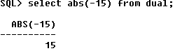

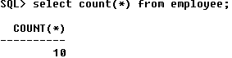

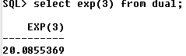

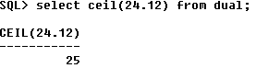

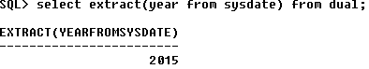

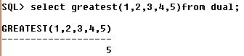

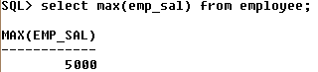

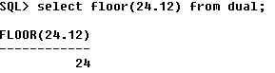

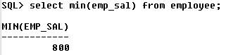

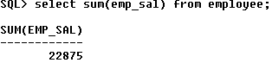

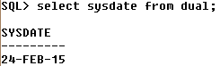

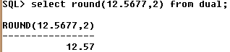

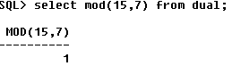

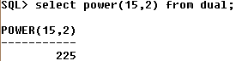

string functions :
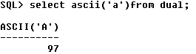

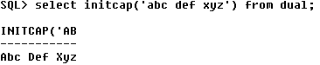
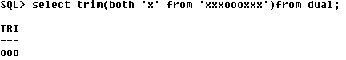

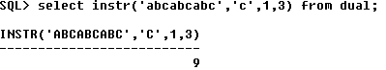

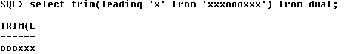

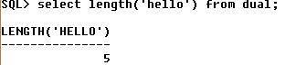

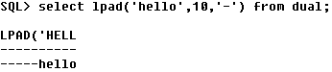
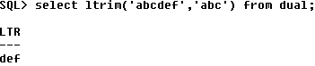
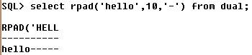

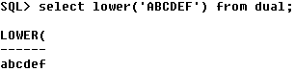

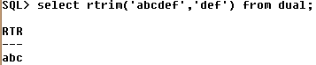

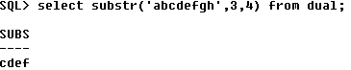

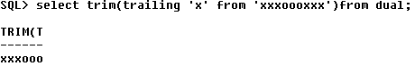

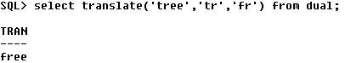

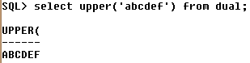

Other functions:

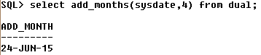

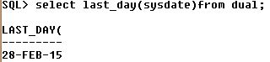

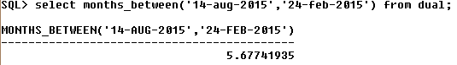

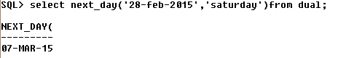

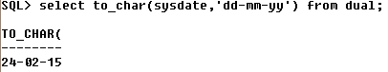

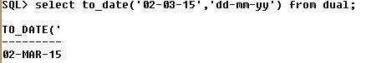

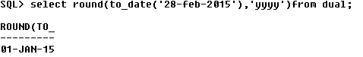

QUESTIONS
1) SQL applies predicates in the _______ clause after groups have been formed, so aggregate functions may be used.
a) Group by
b) With
c) Where
d) Having
View Answer
Answer:b
Explanation:The with clause provides away of defining a temporary relation whose definition is available only to the query in which the with clause occurs..

2) Aggregate functions can be used in the select list or the_______clause of a select statement or subquery. They cannot be used in a ______ clause.
a) Where, having
b) Having, where
c) Group by, having
d) Group by, where
View Answer
Answer:b
Explanation:To include aggregate functions having clause must be included after where.

3) With max_budget (value) as
(select max(budget)
fromdepartment)
select budget
from department, max_budget
wheredepartment.budget = max budget.value;
In the query given above which one of the following is a temporary relation ?
a) Budget
b) Department
c) Value
d) Max_budget
View Answer
Answer:d
Explanation:With clause creates a temporary relation.
Practical-7
Aim: To Solve Various Queries Related To Grouping And Aggregate Functions.

Software required: Oracle SQL

- Insert the following values into product table.
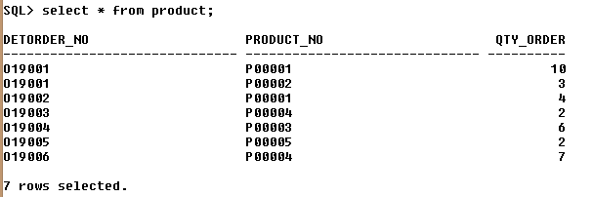

- Retrieve the product numbers and total quantity ordered for each
product from the product table. 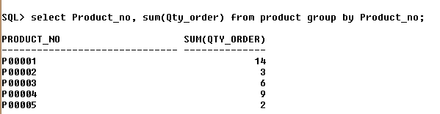

- Retrieve the product no and the total quantity ordered for product’s
‘P00001’ and ‘P00004’ from product table.
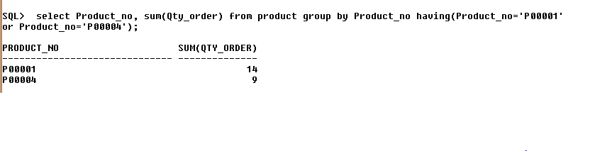
- Insert the following values into emp_company
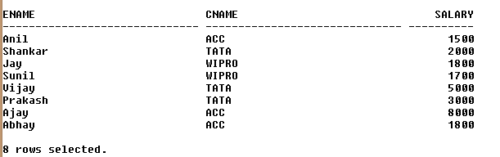
- List the name of company and maximum salary in that company.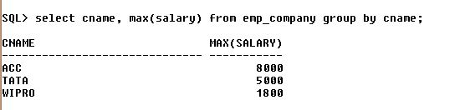

- Find out the average salary of each company.

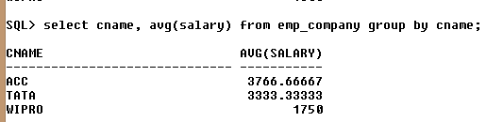

- Find out the name of companies having average salary more than 1500.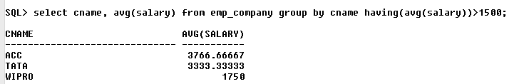

- Find out the average salary of each company except ‘ACC’.
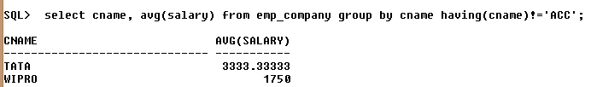

QUESTIONS
1) Which of the following is not a aggregate function ?
a) Avg
b) Sum
c) With
d) Min
Answer:c
Explanation:With is used to create temporary relation and its not a aggregate function.

2) Sub queries cannot:
a) Use group by or group functions
b) Retrieve data from a table different from the one in the outer query
c) Join tables
d) Appear in select, update, delete, insert statements.
Answer:c

3) Aggregate functions are functions that take a ___________ as input and return a single value.
a) Collection of values
b) Single value
c) Aggregate value
d) Both a & b

Answer:a

4) Select __________
from instructor
wheredept name= ’Comp. Sci.’;
Which of the following should be used to find the mean of the salary ?
a) Mean(salary)
b) Avg(salary)
c) Sum(salary)
d) Count(salary)

Answer:b
Explanation:Avg() is used to find the mean of the values.
PRACTICAL 8

Aim:Study the Microsoft Access Tool. Create tables and generate relationship as per
given university schema. Implement Following things in university schema :
- Enforce referential integrity
- Cascade update
- Cascade delete

Software required: Microsoft access.

Knowledge required: general concepts of database, its applications, instances, data models and how to generate a relationship schema.

Theory/logic: Microsoft Access, also known as Microsoft Office Access, is a database management system from Microsoft that combines the relational Microsoft Jet Database Engine with a graphical user interface and software-development tools. It is a member of the Microsoft Office suite of applications, included in the Professional and higher editions or sold separately. Microsoft Access stores data in its own format based on the Access Jet Database Engine. It can also import or link directly to data stored in other applications and databases.

Advantages:
1. Easy to Use – Just like any other Microsoft Office there are ‘Wizards’ that help you throughout in using the application.

2. Greater Storage Capacity – A Microsoft Access database can hold upto 2 GB of data.

3. Flexibility – You need not be well acquainted with using the application as a person with basic computer knowledge can create databases easily.

4. Data Importing – Importing of data into Microsoft Access is quite simple for small amounts of data.

5. Multi-User Support – About ten users in a network can use an Accessed application.

6. Remote Use – There are also possibilities for you to access this application from a different place.

Applications:
The Microsoft® Access Database is made up of 7 major components:
- Tables;
- Relationships;
- Queries;
- Forms;
- Reports;
- Macros;
- Modules.
Users can create tables, queries, forms and reports, and connect them together with macros. The original concept of Access was for end users to be able to access data from any source. Other features include: the import and export of data to many formats including Excel, Outlook, ASCII, dBase, Paradox, FoxPro, SQL Server, Oracle, ODBC, etc.

It also has the ability to link to data in its existing location and use it for viewing, querying, editing, and reporting. This allows the existing data to change while ensuring that Access uses the latest data. It can perform heterogeneousjoins between data sets stored across different platforms. Access is often used by people downloading data from enterprise level databases for manipulation, analysis, and reporting locally.

There is also the Jet Database format (MDB or ACCDB in Access 2007) which can contain the application and data in one file. This makes it very convenient to distribute the entire application to another user, who can run it in disconnected environments.

One of the benefits of Access from a programmer's perspective is its relative compatibility with SQL (structured query language) — queries can be viewed graphically or edited as SQL statements, and SQL statements can be used directly in Macros and VBA Modules to manipulate Access tables.

Conclusion:
Database management is the process of manipulating the stored data to the requirements. Databases are designed to offer an organized mechanism for storing, managing, and retrieving information. Basically database management involves the functions of data storage and retrieval. In some occasions data stored in a database may be edited and manipulated according to the requirements. MS-Access is a perfect tool to do all these kinds of functions.

Schema diagram:

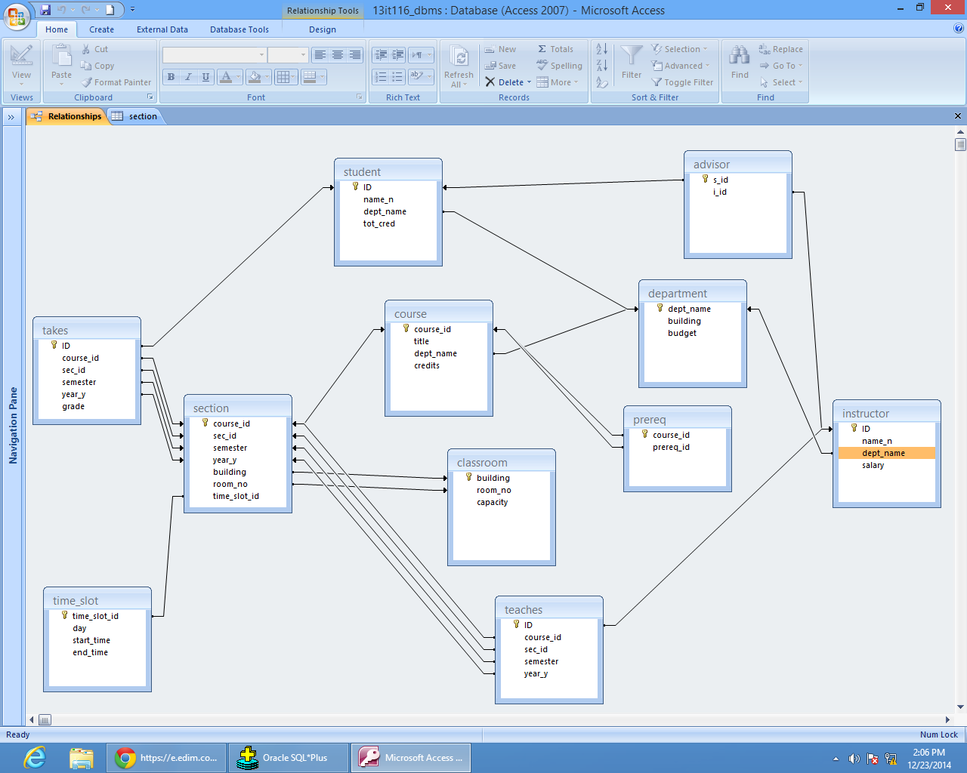

Questions:

Q1) explain the different types of keys used in database.

Keys are, as their name suggests, a key part of a relational database and a vital part of the structure of a table. They ensure each record within a table can be uniquely identified by one or a combination of fields within the table. They help enforce integrity and help identify the relationship between tables.
1) Super Key
A Super key is any combination of fields within a table that uniquely identifies each record within that table.
2) Candidate Key
A candidate is a subset of a super key. A candidate key is a single field or the least combination of fields that uniquely identifies each record in the table. Every table must have at least one candidate key but at the same time can have several.

As an example we might have a student_id that uniquely identifies the students in a student table. This would be a candidate key. But in the same table we might have the student’s first name and last name that also, when combined, uniquely identify the student in a student table. These would both be candidate keys.
In order to be eligible for a candidate key it must pass certain criteria.
- It must contain unique values
- It must not contain null values
- It contains the minimum number of fields to ensure uniqueness
- It must uniquely identify each record in the table
Once your candidate keys have been identified you can now select one to be your primary key

3) Primary Key
A primary key is a candidate key that is most appropriate to be the main reference key for the table. As its name suggests, it is the primary key of reference for the table and is used throughout the database to help establish relationships with other tables. As with any candidate key the primary key must contain unique values, must never be null and uniquely identify each record in the table.
As an example, a student id might be a primary key in a student table.

Primary keys are mandatory for every table each record must have a value for its primary key.

4) Foreign Key
A foreign key is generally a primary key from one table that appears as a field in another where the first table has a relationship to the second. An example might be a student table that contains the course_id the student is attending. Another table lists the courses on offer with course_id being the primary key. The 2 tables are linked through course_id and as such course_id would be a foreign key in the student table.

5) Secondary Key or Alternative Key
A table may have one or more choices for the primary key. Collectively these are known as candidate keys as discuss earlier. One is selected as the primary key. Those not selected are known as secondary keys or alternative keys.
For example in the table showing candidate keys above we identified two candidate keys, studentId and firstName + lastName. The studentId would be the most appropriate for a primary key leaving the other candidate key as secondary or alternative key. It should be noted for the other key to be candidate keys, we are assuming you will never have a person with the same first and last name combination. As this is unlikely we might consider fistName+lastName to be a suspect candidate key as it would be restrictive of the data you might enter. It would seem a shame to not allow John Smith onto a course just because there was already another John Smith.

6) Composite key
A composite key consists of more than one field to uniquely identify a record. Taking the example , imagine we identified a student by their firstName + lastName. In our table representing students on modules our primary key would now be firstName + lastName + moduleCode. Because firstName + lastName represent a unique reference to a student, they are not each simple keys, they have to be combined in order to uniquely identify the student. Therefore the key for this table is a composite key.

Q2) how to enforce referential integrity and what is the use of it ?

Referential integrity between tables is enforced by default when you create a relationship in your database diagram. An enforced relationship ensures each value entered in a foreign key column matches an existing value in the related primary key column.
You can change the conditions under which referential integrity is enforced by editing the relationship's properties.

To change referential integrity options for a new relationship
- In your database diagram, create a relationship. For details, see creating a Relationship Between Tables.
- In the Create Relationship dialog box, clear or select one or more of the options. For information about the options available for SQL Server databases, see Database Designer Considerations for SQL Server Databases. For more information about the options available for Oracle databases, see How Referential Integrity Works with an Oracle Database.

To change referential integrity options for an existing relationship
- In your database diagram, select the relationship line.
- Right-click the relationship line and select Properties.
- Choose the Relationships tab.
- Select the relationship from the Selected relationship list.
- Clear or select one or more of the options. For information about the options available for SQL Server databases, see Database Designer Considerations for SQL Server Databases. For more information about the options available for Oracle databases, see Enforcing Referential Integrity Between Oracle Tables.
The relationship is updated in the database when you save the diagram or either of the related tables.

In simple terms, 'referential integrity' is a guarantee that the target it 'refers' to will be found. A lack of referential integrity in a database can lead relational databases to return incomplete data, usually with no indication of an error.

Q3) which are the different data types supported by access?
Text
Use for text or combinations of text and numbers, such as addresses, or for numbers that do not require calculations, such as phone numbers, part numbers, or postal codes.
Stores up to 255 characters.
Memo
Use for lengthy text and numbers, such as notes or descriptions. Stores up to 65,536 characters.
Number
Use for data to be included in mathematical calculations, except calculations involving money (use Currency type).
Date/Time
Use for dates and times. Stores 8 bytes.
Currency
Use for currency values and to prevent rounding off during calculations.Stores 8 bytes.
AutoNumber
Use for unique sequential (incrementing by 1) or random numbers that are automatically inserted when a record is added.Stores 4 bytes; stores 16 bytes for Replication ID (GUID).
Yes/No
Use for data that can be only one of two possible values, such as Yes/No, True/False, On/Off. Null values are not allowed.Stores 1 bit.
OLE Object
Use for OLE objects (such as Microsoft Word documents, Microsoft Excel spreadsheets, pictures, sounds, or other binary data) that were created in other programs using the OLE protocol.Stores up to 1 gigabyte (limited by disk space).
Hyperlink
Use for hyperlinks. A hyperlink can be a UNC path or a URL.

Practical-9

Aim: To Apply The Concept Of Integrity/Data Constraints While Creating Or Altering Table.

Software required: Oracle SQL

- Create Table Salespeople where
Snumnumber(4) P.K, Sname varchar2(20)NOT NULL, City varchar2(15), Comm number(5,2).
- Create Table customer where
Cnum number (4) P.K, Cnamevarchar2(20)NOT NULL, City varchar2(20), Rating number(3) DEFAULT 10, Snum number(4) F.K.(where snum refer salespeople table).
- Create table Order where
Order_nonumber(4) P.K, Amount number(5), Odate varchar2(10), Cnum number(4) F.K, (where cnum refer customer table). Snumnumber(4) F.K (where snum refer salespeople table).
4. Table: Sales_order

Column Name | Data Type | Contraints
Order_no | Varchar2(6) | Primary key/First letter start with ‘O’
Order_date | Date
Client_no | Varchar2(6) | Foreign Key references client_no of client_master table
Dely_addr | Varchar2(25)
Salesman_no | Varchar2(6) | Foreign Key refrencessales_noofSalesman_master table
Dely_type | char | Delivery: part(P)/ full (f) Default ‘F’
Dely_date | date | Cannot be less than order_date
Order_status | Varchar2 | In Process,Fulfilled,Backorder,Cancelled

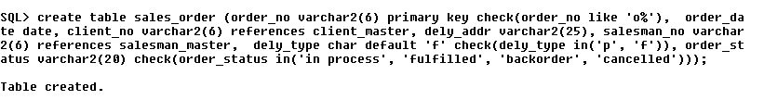

5. Table: salesman_master

Column name | Data type | Constraints
Salesman_no | Varchar2(6) | Primary key/first letter must start with ‘S’
Salesman _name | Varchar2(20) | Not null
Address | Varchar2(30) | Not null
City | Varchar2(20)
Pincode | Varchar2(8)
State | Varchar2(20)
Sal_amt | Number(8,2) | Not null, cannot be 0
Ytd_sales | Number(6,2) | Not null, cannot be 0
Tgt_sales | Number(6,2) | Not null
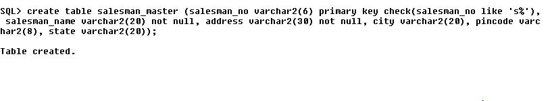
6. Table: Client_master

Column name | Data type | Constraints
Client_no | Varchar2(6) | Primary key/first letter must start with ‘C’
aName | Varchar2(20) | Not null
Address | Varchar2(30)
City | Varchar2(15)
Pincode | Number(8)
State | Varchar2(15)
Bal_due | Number(10,2)

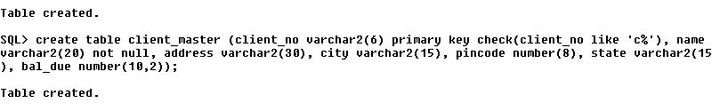
Questions :
1) 1. To include integrity constraint in a existing relation use :
a) Create table b) Modify table
c) Alter table d) Drop table
answer : c
Explanation: SYNTAX – alter table table-name add constraint , where constraint can be any constraint on the relation.

2)Domain constraints, functional dependency and referential integrity are special forms of _________.
a) Foreign key b) Primary key
c) Assertion d) Referential constraint
View Answer
Answer : c
Explanation: An assertion is a predicate expressing a condition we wish the database to always satisfy.

Practical 10

Aim: To solve queries using following different types of join and sub query.
- Equi join
- Cartesian product
- Inner join
- Outer join (left, right, full)
Software required: Oracle SQL

Joint Multiple Table (Equi Join): Sometimes we require to treat more than one table as though manipulate data from all the tables as though the tables were not separate object but one single entity. To achieve this we have to join tables. Tables are joined on column that has same data type and data with in tables. The tables that have to be joined are specified in the FROM clause and the joining attributes in the WHERE clause.

Algorithm for JOIN in SQL:
1. Cartesian product of tables (specified in the FROM clause)
2. Selection of rows that match (predicate in the WHERE clause)
3. Project column specified in the SELECT clause.

1. Cartesian product:-
Consider two table student and course
Select B.*,P.*
FROM student B, course P;
2. INNER JOIN:
Cartesian product followed by selection
Select B.*,P.*
FROM student B, Course P
WHERE B.course # P.course# ;
3. LEFT OUTER JOIN:
LEFT OUTER JOIN = Cartesian product + selection but include rows from the left table which are unmatched pat nulls in the values of attributes belonging to the second table
Exam:
Select B.*,P*
FROM student B left join course p
ON B.course # P.course #;
4. RIGHT OUTER JOIN:
RIGHT OUTER JOIN = Cartesian product + selection but include rows from right table which are unmatched
Exam:
Select B.*,P.*
From student B RIGHT JOIN course P
On B.course# = P course # ;
5. FULL OUTER JOIN
Exam
Select B.*,P.*
From student B FULL JOIN course P
On B.course # = P course # ;

Questions:
- All customers services by Peel or Motika.
- All orders except those with 0 or null value in amt field.
- Largest order taken by each sales order value more than 3000.
- All combination of salespeople and customers who belong to the same city.
- List each order with the name of the customer who placed the order.
- Produce a listing of all the customers serviced by salespeople having commission more than 12%.
- Produce name and cities of all customers with the same rating as Hoffman.
- Count the customers with rating above San Jose’s average.
- Find total amount in orders for each salesperson for whom this total is greater than the amount of the largest order in the order table.
- Create a union of two queries that shows the names, cities and rating of all customers. Those with a rating of 200 or greater will have the words ‘High Rating’ while others will have ‘Low Rating’.

Practical 11

Aim: To perform basic PL/SQL blocks.

Software Required: Oracle 9i Client/Server / Oracle 10g

Knowledge Required: SQL and Pro* Commands

Theory/Logic:

Basic Structure of PL/SQL
PL/SQL stands for Procedural Language/SQL. PL/SQL extends SQL by adding constructs found in procedural languages, resulting in a structural language that is more powerful than SQL. The basic unit in PL/SQL is a block. All PL/SQL programs are made up of blocks, which can be nested within each other. Typically, each block performs a logical action in the program. A block has the following structure:

DECLARE
/* Declarative section: variables, types, and local subprograms. */
BEGIN
/* Executable section: procedural and SQL statements go here. */

/* This is the only section of the block that is required. */
EXCEPTION
/* Exception handling section: error handling statements go here.
END;

Only the executable section is required. The other sections are optional. The only SQL statements allowed in a PL/SQL program are SELECT, INSERT, UPDATE, DELETE and several other data manipulation statements plus some transaction control. However, the SELECT statement has a special form in which a single tuple is placed in variables; more on this later. Data definition statements like CREATE, DROP, or ALTER are not allowed. The executable section also contains constructs such as assignments, branches, loops, procedure calls, and trigger. PL/SQL is not case sensitive. C style comments (/* ... */) may be used.
To execute a PL/SQL program, we must follow the program text itself by
- A line with a single dot ("."), and then
- A line with run;

Variables and Types
Information is transmitted between a PL/SQL program and the database through variables. Every variable has a specific type associated with it. That type can be
- One of the types used by SQL for database columns
- A generic type used in PL/SQL such as NUMBER
- Declared to be the same as the type of some database column

Control Flow in PL/SQL
PL/SQL allows you to branch and create loops in a fairly familiar way.
An IF statement looks like:
IF <condition> THEN
<statement_list>
ELSE
<statement_list>
END IF;

The ELSE part is optional. If you want a multiway branch, use:

IF <condition_1> THEN ...

ELSIF <condition_2> THEN ...

... ...

ELSIF <condition_n> THEN ...

ELSE ...

END IF;

Loops are created with the following:

LOOP
<loop_body> /* A list of statements. */
END LOOP;

At least one of the statements in <loop_body> should be an EXIT statement of the form
EXIT WHEN <condition>;
The loop breaks if <condition> is true.

Some other useful loop-forming statements are:
- EXIT by itself is an unconditional loop break. Use it inside a conditional if you like.
- A WHILE loop can be formed with
WHILE <condition> LOOP
<loop_body>
END LOOP;
- A simple FOR loop can be formed with:
FOR <var> IN <start>..<finish> LOOP
<loop_body>
END LOOP;
Here, <var> can be any variable; it is local to the for-loop and need not be declared. Also, <start> and <finish> are constants.

- Program: Display square of given no from 1 to 10 using loop, for and while.

Code:
Declare
no number(3);
sqr number(3);
Begin
no := 1;

while no >=10
loop
sqr := no * no;
dbms_output.put_line(sqr);
no := no + 1;
end loop;

End;
Using For Loop:
Declare
no number(3);
sqr number(3);
Begin
no := 1;

for no in 1..10 loop
sqr := no * no;
dbms_output.put_line(sqr);
end loop;

End;

Output:-----

.

Application: Data processing

Question:
- What are the additional data types supporting in oracle10g?
- Explain advantages of PL/SQL over SQL?
- What steps are included in compilation process of PL/SQL block

Practical – 12

Aim: Write a program to implement trigger: Write a PL/SQL block to update the balance. Generate trigger that will store the original record in other table after updation take place.

Software Required: Oracle 9i Client/Server / Oracle 10g

Knowledge Required: Trigger.

Theory/Logic:

A database trigger has three basic parts.

- A triggering event.

It is a SQL statement that causes a trigger to be fired i.e. INSERT, DELETE,
UPDATE.
- A triggering restriction.

It specifies a Boolean expression that must be true.
- A triggering action.

A trigger action is the PL/SQL code to be executed when a triggering action is
encountered if the triggering restriction evaluates to true.

Types of trigger:
- Row trigger
A row trigger is fired each time a row in the table is affected by the triggering statement.
- Statement trigger:
A statement trigger is fired once on a behalf of the triggering statement, independent of the number of rows the triggering statement affects.
- Before V/s After trigger:
Before triggers execute the trigger action before the triggering statement whereas after triggers execute the trigger action after the triggering statement.
Use the following guidelines when designing your triggers:
- Use triggers to guarantee that when a specific operation is performed, related actions are performed.
- Do not define triggers that duplicate features already built into Oracle Database. For example, do not define triggers to reject bad data if you can do the same checking through declarative integrity constraints.
- Limit the size of triggers. If the logic for your trigger requires much more than 60 lines of PL/SQL code, it is better to include most of the code in a stored procedure and call the procedure from the trigger.
- Use triggers only for centralized, global operations that should be fired for the triggering statement, regardless of which user or database application issues the statement.
- Do not create recursive triggers. For example, creating an AFTER UPDATE statement trigger on the Emp_tab table that itself issues an UPDATE statement on Emp_tab, causes the trigger to fire recursively until it has run out of memory.
- Use triggers on DATABASE judiciously. They are executed for every user every time the event occurs on which the trigger is created.
Syntax for creating a trigger
create or replace trigger <TRIGGER_NAME>
{before, after} {delete, insert ,update [OF column, …]}
on <table_name>
[for each row][when condition]
declare
<VARIABLE DECLARATIONS> <CONSTANT DECLARATIONS>
begin
<CODE>
exception
<EXCEPTION HANDLERS>
end <TRIGGER_NAME>;

Code:
CREATE TRIGGER audit_trail
AFTER UPDATE OR DELETE ON client_master
FOR EACH ROW
Declare
oper varchar2(8);
client_no varchar(5);
name varchar(10);
bal_due number (7);

Begin
IF updating THEN
oper := ‘update’;
END IF;

IF delating THEN
oper := ‘delete’;
END IF;

client_no := : old.client_no;
name := : old.name;
bal_due := : old.bal_due;

INSERT INTO auditclient
VALUES (client_no, name, bal_due, oper, user, sysdate);
End;

Application:

- Can be used in any company to maintain client information, product information and sales information.

- It is used to keep track of records deleted or updated.

Question/Answer:

- Explain uses of database trigger.
- Explain trigger execution hierarchy.
- What is the maximum number of trigger that can be applied to single table?

